

**Name**

Talha Abdullah Bangyal

**Roll Number**

SU92-BAIFM-F25-002

**Section**

BAI-3C

**Subject**

Data Structure (Lab)

**Submitted To**

Philemon Philip

**Task 1**

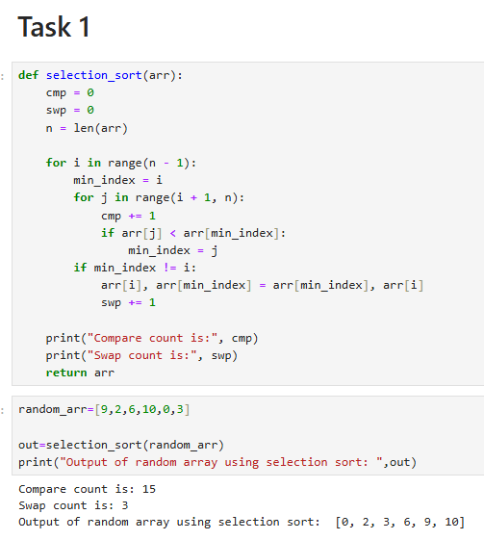

**Task 2**

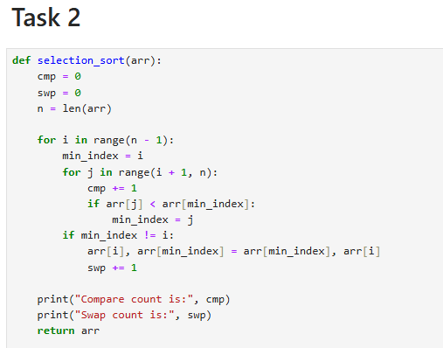

**Task 3**

